Appendix 20 – Research performance, at national and international level

JOURNALS PUBLISHED UNDER UNIVERSITY’S AEGIS
- Notulae Botanicae Horti Agrobotanici Cluj-Napoca (A)
- Bulletin of University of Agricultural Sciences and Veterinary Medicine Cluj-Napoca. Agriculture (B+)
- Bulletin of University of Agricultural Sciences and Veterinary Medicine Cluj-Napoca. Horticulture (B+)
- Bulletin of University of Agricultural Sciences and Veterinary Medicine Cluj-Napoca. Animal Breeding and Biotechnology B+)
- Bulletin of University of Agricultural Sciences and Veterinary Medicine Cluj-Napoca. Veterinary Medicine (B+)
- Agricultura – revistă de ştiinţă şi practică agricolă (B+)
- Notulae Scientia Biologicae
- Revista Scientia Parasitologica
- ProEnvironment/ProMediu
- Clujul Medical Veterinar
- Protecţia plantelor
- Hameiul şi plantele medicinale
- The Romanian Society for Grassland Journal (2 issues/year)
- Hortus Agrobotanicus Napocensis - Index Seminum (1 issue/year)

The journal ”NOTULAE BOTANICAE HORTI AGROBOTANICI CLUJ-NAPOCA” indexing by Thomson Reuters
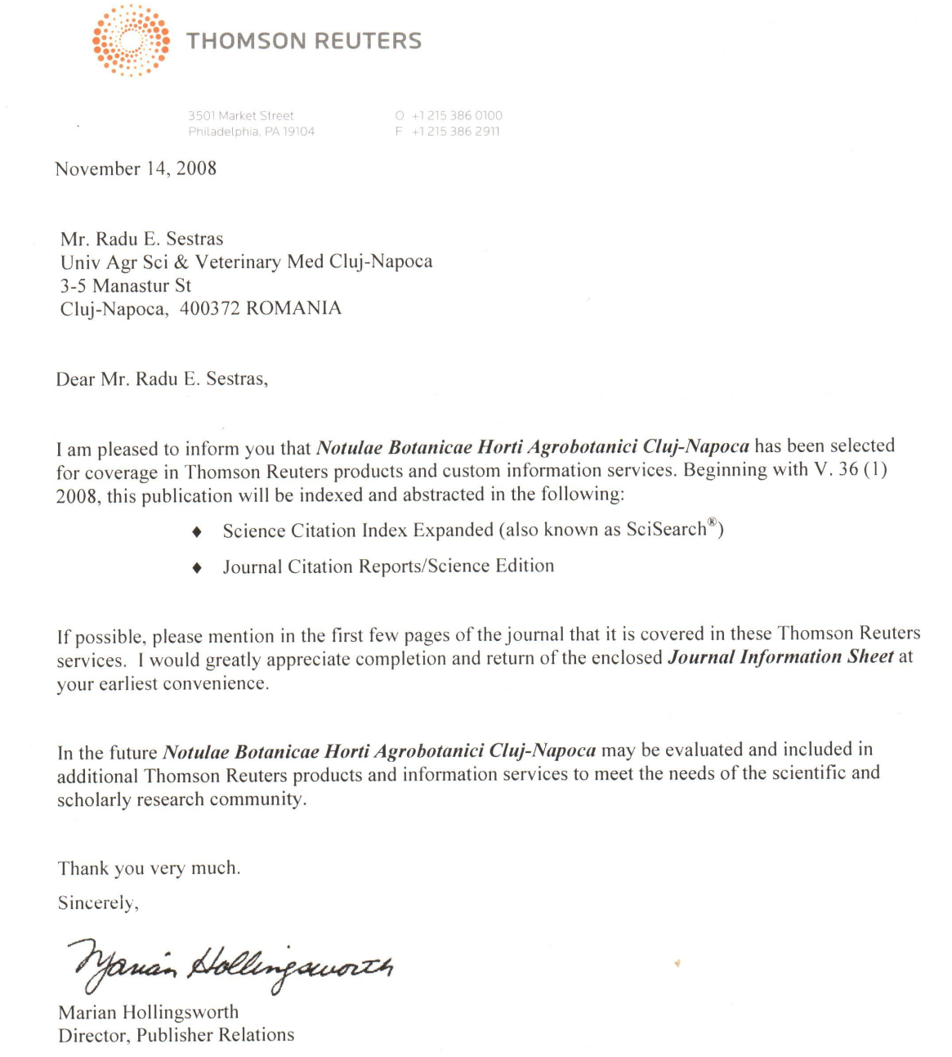
ISI Impact factor = 0.468

UNIVERSITY’S ACADEMIC PERSONALITIES ELECTED AS ACADEMY MEMBERS

- Doru PAMFIL, PhD, Professor | Romanian Academy Corresponding Member
- Alexandru SALONTAI, PhD, Professor | Honorary Member of the Romanian Academy of Agricultural and Forestry Sciences "Gheorghe Ionescu – Sisești”
- Eronim ŞUTEU, PhD, Professor | Honorary Member of the Romanian Academy of Agricultural and Forestry Sciences "Gheorghe Ionescu – Sisești”
- Leon Sorin MUNTEAN, PhD, Professor | Full Member of the Romanian Academy of Agricultural and Forestry Sciences "Gheorghe Ionescu – Sisești”
- Alexandru Ioan BABA, PhD, Professor | Full Member of the Romanian Academy of Agricultural and Forestry Sciences "Gheorghe Ionescu – Sisești”
- Mihai RUSU, PhD, Professor | Full Member of the Romanian Academy of Agricultural and Forestry Sciences "Gheorghe Ionescu – Sisești”
- Liviu Al. MĂRGHITAŞ, PhD, Professor | Full Member of the Romanian Academy of Agricultural and Forestry Sciences "Gheorghe Ionescu – Sisești”
- Vasile COZMA, PhD, Professor | Full Member of the Romanian Academy of Agricultural and Forestry Sciences "Gheorghe Ionescu – Sisești”
- Viorel BUDIU, PhD, Professor | Corresponding Member of the Romanian Academy of Agricultural and Forestry Sciences "Gheorghe Ionescu – Sisești”
- Ioan HAŞ, PhD, Professor | Corresponding Member of the Romanian Academy of Agricultural and Forestry Sciences "Gheorghe Ionescu – Sisești”
- Ioan GROZA, PhD, Professor | Corresponding Member of the Romanian Academy of Agricultural and Forestry Sciences "Gheorghe Ionescu – Sisești”
- Petru GUŞ, PhD, Professor | Associate Member of the Romanian Academy of Agricultural and Forestry Sciences "Gheorghe Ionescu – Sisești”
- Doru PAMFIL, PhD, Professor | Associate Member of the Romanian Academy of Agricultural and Forestry Sciences "Gheorghe Ionescu – Sisești”
- Silviu Al. APAHIDEAN, PhD, Professor | Associate Member of the Romanian Academy of Agricultural and Forestry Sciences "Gheorghe Ionescu – Sisești”
- Radu SESTRAŞ, PhD, Professor | Associate Member of the Romanian Academy of Agricultural and Forestry Sciences "Gheorghe Ionescu – Sisești”
- Ioan BUD, PhD, Professor | Associate Member of the Romanian Academy of Agricultural and Forestry Sciences "Gheorghe Ionescu – Sisești”
- Gheorghe RĂPUNTEAN, PhD, Professor | Associate Member of the Romanian Academy of Agricultural and Forestry Sciences "Gheorghe Ionescu – Sisești”
- Marina SPÎNU, PhD, Professor | Associate Member of the Romanian Academy of Agricultural and Forestry Sciences "Gheorghe Ionescu – Sisești”
- Carmen SOCACIU, PhD, Professor | Associate Member of the Romanian Academy of Agricultural and Forestry Sciences "Gheorghe Ionescu – Sisești”
- Alexandru NAGHIU, PhD, Professor | Associate Member of the Romanian Academy of Agricultural and Forestry Sciences "Gheorghe Ionescu – Sisești”
- Emilian MERCE, PhD, Professor | Associate Member of the Romanian Academy of Agricultural and Forestry Sciences "Gheorghe Ionescu – Sisești”

